10 reasons to join the PTA

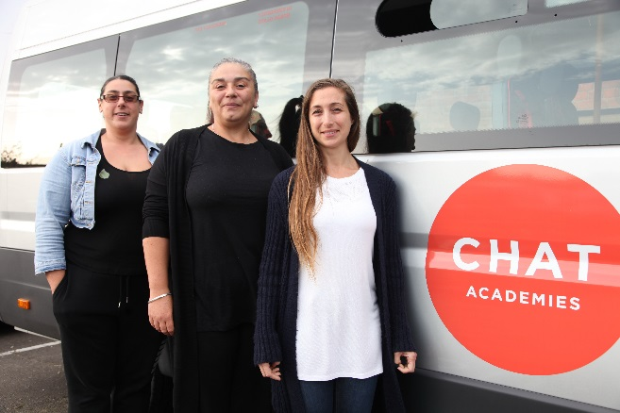
Supporting your school's parent teacher association need not be a chore. Get involved, help out at a school fundraiser and have some fun!

We all want our children’s schools to be the very best they can. One of the ways we can help best is by joining the PTA and getting involved in the life of the school. It is not just our children and the school that benefits. You might just find you end up involved in a lot of fun too.

1. You’ll make a difference.
By volunteering with the PTA, you’ll be able to use your skills to help the school. Parent groups work to establish a supportive and encouraging community for the entire school.

2. It’s fun!
You’ll connect with a group of people who are all concerned with creating a better environment for their children. You will help plan fun events, socials and get togethers that everyone can attend.

3. It’s important to the school.
Schools are becoming more and more dependent on active parent groups. Parent groups are responsible for helping to raise much needed funds. But just as importantly, a great PTA helps to create a caring, welcoming and supportive atmosphere in the school. By joining the PTA you will also have the chance to promote and enhance your school's standing within your local community

4. You’ll help raise necessary funds.
Fundraisers remain important to improving the quality of the school overall, and parent groups make them possible. We are always looking for ideas.

5. You’ll get connected.
There’s no better way to know what’s going on in the school than to be on the school’s parent teacher group. Being part of the PTA helps you get to know other parents and their children. This is important for school matters but also great for a more active social life.

6. You’ll be part of a network.
Every parent group activity is an opportunity to meet other parents in the same situation as you. You will be connected with a group of parents who share a common goal of improving the school for the children.

7. You’ll be a role model.
You’ll show your children that not only are they important to you, but their education is as well. They’ll see you getting involved to help make the school better for them and their peers,
and chances are they’ll do the same.
8. It’s for every parent.
Your voice and opinion matters! It makes a difference when you speak up. Your voice and ideas can help improve the school. Whether you can make costumes for the Christmas play, bake cakes, manage money or come up with new fundraising ideas, your skills are valuable to your school. The PTA gives you an opportunity to put your skills to good use and they will always be gratefully received.

9. You can be flexible.
There are a variety of small ways parents can help and be involved in the PTA. You can choose. Responsibilities are flexible and can be adjusted to fit with your time constraints. If you work it out the commitment is not too much. The occasional evening meeting and the odd summer fete or other school fundraiser.

10. It’s good for your child.
10 Reasons to Join the PTA © 2010 Believe Kids
Research shows that children whose parents are involved in their school get better results and have fewer disciplinary problems at school. When parents get more involved the school,
their children do better.
For more information about getting involved [email contact]

